Food Standards Australia New Zealand
Government Costs Associated with the Implementation of New Food Regulation
Findings from a Food Standards Australia New Zealand economic evidence project report prepared for the Australian Department of Health
March 2017

Contents
Contents 1
Table of abbreviations 2
Executive summary 3
1 Introduction 5
1.1 Background 6
2 Research objective, design and information gathering process 7
2.1 Project objectives 7
2.2 Project design 8
2.2.1 Project initiation 8
2.2.2 Pilot data collection 9
2.2.3 Data collection 9
2.2.4 Analysis and development 10
2.2.5 Consultation and refinement 11
3 Consideration of which agency implementation activities should and should not be taken into account 11
3.1 Agency costs 11
3.1.1 Policy type activities 11
3.1.2 Compliance type activities 13
3.1.3 Enforcement type activities 13
3.1.4 Food incidents management type of activities 14
3.2 Agency benefits 15
4 Government Implementation Cost Framework 16
4.1 Materiality decision tool 17
4.2 Costing tool 22
4.2.1 The process of using the costing tool in the RIS structure 23
4.2.2 Quantifying costs and benefits 24
4.2.3 Calculating net present value 26
4.3 Engaging with agencies on-costs 26
5 Possible next steps 27
6 Conclusions 27
7 Appendix 1 – Components of the cost-benefit analysis 28
8 Appendix 2 – Australian and New Zealand Regulatory Agencies 30
9 Appendix 3 – Survey Participants 32
10 Appendix 4 – Quantifying jurisdictions’ costs 33
10.1 Example 1; small review of existing standard 33
10.2 Example 2; new standard 35

Table of abbreviations
CBA Cost-benefit analysis
COAG Council of Australian Governments
CRIS Consultation Regulatory Impact Statements
FRSC Food Regulation Standing Committee
FSANZ Food Standards Australia New Zealand
FTE Full-Time Equivalent
MPI New Zealand Ministry of Primary Industries
OBPR Office of Best Practice Regulation
RIS Regulatory Impact Statement
SSEAG Social Science and Economic Advisory Group

Executive summary
Food Standards Australia New Zealand (FSANZ) is an Australian Government agency that develops and administers the Australia New Zealand Food Standards Code (the Code). The Code is implemented and enforced by state, and territory agencies, the New Zealand Ministry for Primary Industries and the Department of Agriculture and Water Resources (for food imported into Australia.
The Food Standards Australia New Zealand Act 1991 requires FSANZ to consider costs in decision-making. As a standard setting body, FSANZ is required to comply with the Council of Australian Governments (COAG) regulatory impact analysis requirements administered by the Office of Best Practice Regulation (OBPR). FSANZ is required to submit a Regulatory Impact Statement (RIS) to the OBPR for all decisions made that would encourage, or force, businesses or individuals to pursue their interests in ways they would not otherwise have done, unless the impact is minor.
The Commonwealth Department of Health contracted FSANZ to develop an activity-based costing model for government costs associated with changes to the Code. The model will form part of the response to the Australia and New Zealand Ministerial Forum on Food Regulation (the Forum) for the Review of Food Labelling Law and Policy.
The project has involved:
- systematic consultation with all Australian state and territory agencies, the New Zealand Government and a number of local government bodies
- collection of readily available costing information held by agencies and a number of local government bodies
- categorisation of the implementation costs associated with changes to the Code to the agencies
- assessment of this data with respect to estimating costs and benefits associated with a change to the Code.
Regulatory impact analysis of a new piece of legislation estimates the impact of changing from the current conditions (status quo) by considering costs that arise from the regulation being incorporated into the existing food regulatory system. FSANZ has examined relationships between changes to the Code and jurisdictional implementation costs. A subset of jurisdictional implementation costs were considered to be out-of-scope because they were not typically required by the OBPR and did not fit within standard approaches to cost-benefit analysis.
From the range of costs considered, three classes of activities were within scope, namely:
- development of the implementation strategy
- physical implementation of the new regulation into the food regulatory system
- ongoing administration of the regulation.
A Government Implementation Cost Framework (the framework) was developed in order to perform two functions. The first function was to help determine whether the jurisdictions’ costs were material to the regulatory impact analysis and so required expression in monetary terms. The second function was to estimate the size of the jurisdiction’s net cost if necessary. The framework comprised an indicative materiality tool and a costing tool. The project has found a number of consistent factors that influence the jurisdictions implementation costs. These include:
- whether the industry is presently regulated and the level of that regulation
- the number of businesses affected by the change
- the skills and systems that industry may already have in place to manage the new regulatory requirements
- if food safety plans need to be changed, or put in place, in order to comply with any Code changes
- whether the changes are required to be legislated or gazetted by the jurisdictions in order to legalise the changes to their food safety system.
If the factors listed above are unlikely to be material to the jurisdiction’s costs then a quick decision can be made to limit research effort to more relevant areas. Increasing the number of the above factors involved increases the likelihood that the jurisdictions’ implementation costs will be a significant component in FSANZ’s regulatory impact analysis and so require in-depth cost review.
Effective models require balance between accuracy, reflection of real-world issues, reliability, and ease of use. The usability of the materiality tool is enhanced by using proxy measures to indicate ‘the complexity of the change to the Code’, and ‘the level of the regulatory sophistication of the affected businesses’.
The costing tool is built around information and data provided during consultation with the agencies. The tool is based on a simplified activity-based costing approach. The values calculated using the model will act as a starting point for further discussions with jurisdictions.
This approach allows costs to be calculated by identifying the activities involved in implementation and assigning a cost to each activity, based on required resources.
It is anticipated that the framework will be refined and developed over time with the collection of improved costing data and increased experience in estimating government costs, and this will assist FSANZ in optimising regulatory design. It is FSANZ’s intention that this ongoing process will take place in close partnership with the food regulators.

Introduction
Food Standards Australia New Zealand (FSANZ) maintains the joint food standards set out in the Australia New Zealand Food Standards Code (the Code).
As a standard setting body, FSANZ is required to comply with the Council of Australian Governments (COAG) best practice regulation and regulatory impact analysis requirements as administered by the Office of Best Practice Regulation (OBPR) . FSANZ is required to submit a Regulatory Impact Statement (RIS) to the Office of Best Practice Regulation (OBPR) for all decisions made that would encourage or force businesses or individuals to pursue their interests in ways they would not otherwise have done, unless the impact is minor. The RIS aims to be a balanced, structured examination of the considered options in order to address the food-related risk or other objective (risk management options). The purpose of a RIS is to draw conclusions on whether regulation is appropriate, and if so, which of the considered risk management options is the most efficient and effective approach. The OBPR independently assesses the RIS quality of analysis.
Cost-benefit analysis (CBA) is often a key component of the RIS as it can assist in identifying the risk management option that offers the greatest net benefit to the Australian and New Zealand communities. The risk management option that is most likely to provide the greatest net benefit to the Australian and New Zealand communities is generally recommended as the preferred option.
In addition to the administrative COAG requirements, sections 29 and 59 of the Food Standards Australia New Zealand Act 1991 stipulates that FSANZ must have regard to whether the costs that would arise from a food regulatory measure outweigh the direct and indirect benefits to the community, Government, or industry.
The costs and benefits included in the CBA are those that are incurred as a result of adopting the risk management option. That is, from the base case of status quo, it is the additional or incremental, costs and benefits that would arise from the risk management option being incorporated into the existing food regulatory system.
The preferred risk management option is the option that is most likely to provide the greatest net benefits to the Australian and New Zealand communities. The overall net benefit can be calculated from the net cost estimates of the government, industry, and consumer segments of the CBA (refer appendix 1). Improving the accuracy of the net cost estimates of each of the segments is a worthwhile investment of resources where that segment is likely to influence which of the risk management options will be the preferred option.
There are two components of the net cost estimate that influence its significance in a CBA, namely the magnitude of the net cost estimate in relation to the other segments, and the accuracy of the net cost estimate. Better information often reduces the uncertainty surrounding estimates, however if that segment of costs is already known to be immaterial in deciding the preferred option, then the value of the additional information may be negligible. Undertaking a comprehensive CBA process can be time consuming and costly, and in the context of a tight fiscal environment, it is important that FSANZ allocates resources strategically to where they can most efficiently influence regulation design.
FSANZ has experienced some challenges in quantifying the regulatory impact of Code changes on the jurisdictions. FSANZ often receives only a few submissions, or limited information in submissions detailing the agencies’ costs associated with incorporating Code changes into their food regulatory system.
This often means that FSANZ has to rely on limited information that is not necessarily representative of all jurisdictions and may not account for the legitimate variation of net costs between jurisdictions. This makes it difficult to estimate the net costs for the government segment of a CBA, and to determine likely materiality and accuracy of the information provided or generated.
The potential uncertainty in quantifying government costs could, in some instances, limit FSANZ’s ability to accurately evaluate proposed changes to the Code and thus optimise regulation design.

Background
FSANZ was contracted by the Department of Health to develop an activity-based costing model for government costs in order to inform the response to the Australia and New Zealand Ministerial Forum on Food Regulation (the Forum) to the Review of Food Labelling Law and Policy.
FSANZ thus undertook a project to develop a Government Implementation Cost Framework (the framework) to assist in determining if the jurisdictions’ costs are likely to be material to decision-making and, if so, to estimate the size of the jurisdiction’s net cost. The framework comprises:
- an indicative materiality decision tool (materiality tool) which is a qualitative assessment of the likelihood that the jurisdictions’ cost of implementing food regulation will be material for each specific risk management option
- a costing tool for calculating a quantitative estimation of the net costs for each jurisdiction for the specific risk management option, if the indicative decision tool suggests a material cost of implementation. The values calculated by the costing tool will act as a starting point for consultation with the jurisdictions.
The development process of the framework and its possible future is set out below.
This paper has the following narrative structure.
- Research objective, design and information gathering process. This section discusses the objectives in developing a Government Implementation Cost Framework and the project methodology.
- Consideration of agency implementation activities. This section discusses the typical activities that agencies undertake when incorporating new food regulation into the jurisdiction’s food regulatory system. The section also discusses which of these activities is appropriate to be captured in FSANZ regulatory impact analysis.
- Government Implementation Cost Framework. This section outlines the framework and the two tools it comprises. It also discusses how the framework can be used to more effectively engage with the agencies on their costs and improve the accuracy of the initial net cost estimation.
- Possible next steps. This section offers possible means for progressing the framework.
- Conclusion.

Research objective, design and information gathering process

Project objectives
FSANZ has undertaken a project to assist in future estimation of jurisdictions’ costs associated with implementing changes to the Code. This involves:
- Identification of the significant activities agencies undertake in interpreting, implementing and administering changes to the Code. Then determining which are appropriate to include in FSANZ regulatory impact analysis.
- Determination of how these activities can be quantified for the purpose of CBA.
- Identification of what attributes or context of a change influence implementation and enforcement costs.
- Development of a Government Implementation Cost Framework.
The Government Cost Framework intends to:
- Provide an indication of the significance of the jurisdictions’ costs -Undertaking a comprehensive CBA process can be time consuming and costly, both for FSANZ and the agencies involved. Better information often reduces the uncertainty surrounding estimates, however if the government costs of a risk management option are already known to be relatively small, these costs are likely to be immaterial to the ordering of options and the value of the additional information may be negligible. Having a clear decision-making process around determining the materiality of costs will assist FSANZ in allocating scarce resources to where they might more effectively influence better regulation design.
- Calculate an initial estimate of the jurisdictions’ net costs through a Costing tool - Due to the complexities of the food regulatory system and the lack of cost data presently available, this estimate will indicate the size of the costs but may not do so with a high degree of accuracy in a number of circumstances. This preliminary cost estimate will provide a starting point for consultation with the agencies by clearly conveying the types of costs that make up the estimate and the assumptions of how the agencies would be affected by Code changes. The aggregated results produced by the costing tool could also possibly be used as default values to be placed in Consultation RISs (CRIS) when it appears too difficult or costly relative to the value of the information to seek increased certainty or accuracy.
Standardising the quantification of agencies’ costs fits into FSANZ’s ongoing process of progressively moving parts of its CBA calculations into costing tools and models to improve the timeliness, transparency and methodological robustness of its regulatory impact analysis. These costing tools estimate the monetary value of various types of potential impacts associated with changes to the Code, and include the following components:
- a food labelling model – to estimate the costs to businesses of labelling or relabelling of food and beverages
- a business compliance model – provides estimates of costs to businesses for new food regulations
- a cost of illness model – estimates the cost of various foodborne illnesses.

Project design
Project stages include:
- initiation
- pilot data collection
- further data collection
- analysis of information collected
- development of the first version of the Government Implementation Cost Framework
- consultation on findings
- framework refinement.

Project initiation
The project began with a review of key literature and scoping of the feasibility of the project utilising experts in the field, including the Productivity Commission and economists, including FSANZ’s Social Science and Economic Advisory Group (SSEAG).
As a result of the desktop-research undertaken in this phase, FSANZ focused on a simplified activity-based costing approach in order to obtain maximum usability of any eventual costing tool. This approach allocates implementation costs to each risk management option based on the activities necessary to incorporate the Code change into the jurisdictions’ food regulatory system. Although this is more detailed information than would be described in a CBA, having information on the work undertaken to introduce new food standards in different scenarios enables a picture to be built of how the nuanced differences between the risk management options could influence project costs.
With this approach, costs to each agency can be calculated by identifying the activities involved and assigning a cost to each activity-based on the required resources. The costs of each agency in the jurisdiction would then be combined to obtain a net cost for each jurisdiction.
Any economic model or theory is necessarily a simplification of the real-world situation. In developing the Costing tool this causes a trade-off between the data intensity and complexity of the tool with the accuracy of its outputs and ease-of use. In order to balance the competing priorities in design, criteria were created to guide the development of the costing tool. These criteria included assessment of:
- Meaningfulness to the agencies – the costing tool is a starting point for predicting the jurisdictions costs. Further engagement with the agencies is essential for meaningful cost predictions, to ensure that this engagement is effective, agencies be able to easily relate to the cost categories so they can participate in the costing process and be able to justify how costs were expected to deviate from preliminary estimates.
- Cost driver homogeneity – cost categories are grouped together where they have similar unit costs and are influenced by similar cost drivers.
- Agency based focus – the model should objectively, consistently and accurately reflect the actual activities that the agencies undertake to incorporate the change to the Code into their regulatory system. To meet this objective, the model needs to be able to reflect the underlying regulatory context of the jurisdiction.
- Transparency – the model needs to have a sensible link between the activities that agencies undertake to incorporate the change to the Code into their food regulatory system and the factors that are likely to influence the amount of work required to successfully undertake each of the activities (the cost drivers).
- Capacity for improvement – the model should be able to be improved as further information and more relevant cost data becomes available.
- Administration and operational feasibility – the model needs to be fit for purpose, useable and maintainable for FSANZ.

Pilot data collection
A pilot consultation was undertaken using Tasmania to shape the data collection process. Initial discussions refined the understanding of how the state’s food regulatory agencies interacted, the activities and costs of the food safety system, the incremental work involved in implementing changes to the system, and broad cost and work categories. With the assistance of the agencies, the factors likely to influence the costs involved in the activities were identified and based on this, a draft government costing tool was developed.
The pilot study indicated that it was unlikely that precise cost data directly associated with implementing Code changes was obtainable and so information collected would be of a qualitative nature in some instances. Building on the experience with Tasmania and including academic advice, case studies of recent changes to the food standards were used in order to prompt discussion on the typical activities the agencies would undertake to incorporate a Code change into their regulatory system.
Not only did the case studies identify the activities that the agencies undertake to implement a change to the Code, but they also provided a means to determine how the heterogeneous underlying regulatory context affects the implementation activities. Comparison of differences due to the underlying regulatory context of the jurisdiction when agencies introduced the same change to the Code was instrumental in being able to determine factors that are likely to drive implementation costs given the information was qualitative in nature.

Data collection
FSANZ collaborated with EY, a large and experienced consulting firm with extensive experience in government and data collection, to undertake the explorative information collection process. This phase of the project involved the following steps.
- A data collection strategy – development of a strategy for data collections based on findings from the pilot study and an EY desktop review of the key agencies and their approaches to food regulation. The strategy involved developing a survey and case study questions tailored to each agency.
- Data collection – This involved all Australian state and territory food regulatory agencies, two local councils from each jurisdiction, the New Zealand Ministry for Primary Industries and the Australian Department of Agriculture and Water Resources. Data collection was undertaken using a two-stage approach of in-depth face-to-face consultations with agencies in New South Wales and Victoria, and a survey of the remaining Australian and New Zealand agencies. The face-to-face agency consultations were staggered to allow for the incorporation of lessons learnt from each set of consultations into the data collection strategy, in order to ensure maximum value from the consultations and consistency in data collection. Detailed agendas to facilitate discussion were developed. The survey of the remaining agencies involved a two-page ‘data guidance’ document, which outlined the objective of the project and the data being sought and used examples.
- Data quality assurance – checks on the completeness, accuracy and consistency of the data collected were undertaken throughout the whole process.
New Zealand government, and Australian state and territory government agencies were approached to participate in the project, as well as two local government councils from each state. We were unable to obtain information from the Northern Territory, Queensland Department of Health or the New Zealand Ministry for Primary Industries.
This data collection phase took three months and generated a significant volume of data and information from the 31 agencies that participated.
Information was collected on the activities that could be involved in incorporating a Code change into the jurisdictions’ food regulatory system; how to estimate the cost of each activity and the factors that are cost drivers for each of the activities. The characteristics of the risk management options that might influence costs and the underlying regulatory context are collectively referred to as ‘cost drivers’.
The jurisdictions have key inherent differences, or underlying regulatory context, which means that each agency is uniquely affected by each risk management option and that each has different unit costs associated with implementation activities. The underlying regulatory context of the jurisdictions is influenced by factors such as:

- industry type and concentrations of industries
- differing numbers, types and sizes of businesses within the industries
- agency approaches to food safety and levels of business support
- extent of the use of Third Party Auditors (TPAs) for the specific industry or type of business
- level of delegation to local councils
- schemes for setting fees and audit/inspection frequency
- any requirement to have on-site food safety supervisors
- previously existing jurisdiction-based regulation
- remoteness and wage costs
- roles and responsibilities of the agencies in the jurisdictions.
Not only do these factors differ between the jurisdictions, but there is also significant variation within jurisdictions as most local councils have independence in setting audit or inspection schedules and in determining fees for businesses within their area.
The heterogeneous starting points (i.e. existing jurisdiction regulation) and end points (i.e. different implementation strategies), different geographical factors and concentrations of industries and businesses have highlighted the potential inappropriateness of extrapolating data across the different jurisdictions. An aggregate national tool could not consistently and accurately capture implementation costs that reflect the differing realities of each of the jurisdictions.
Thus the simplified activity-based costing approach provides FSANZ with the flexibility to reflect the numerous facets that influence government implementation costs, whether it be the underlying context of the jurisdiction, or nuanced differences between the risk management options.

Analysis and development
This phase aimed to determine if there are commonalities across the agencies in activities undertaken and if these common activities could be converted to a monetary value as well as how they should be incorporated into the FSANZ CBA framework.
As anticipated from the pilot study, the data that the agencies hold does not necessarily capture the incremental net costs of incorporating Code changes into their food regulatory systems. However, the qualitative information collected from the case studies highlighted strong similarities in the implementation strategies of the food regulatory agencies. The similarities in the implementation activities enabled a theoretical structure to be developed to isolate those activities specific to incorporation of Code changes.
Ideally, the costs of the implementation activities would have been directly observable and steered the theoretical structure for estimating these costs. The Government Cost Framework captures costs incurred because the agencies need to introduce the change to the Code into the food regulatory system of the jurisdiction. The agencies undertake a significant body of work in the normal administration of the food regulatory system, and the work involved in introducing many of the changes to the Code are generally small (e.g. small labelling changes or allowance of an additional food additive). Perhaps because of this, there is limited data captured on the incremental work involved in implementation. Although the jurisdictions were not able to provide the incremental cost data, they were able to provide general costs on administering the food safety system in their jurisdictions, and from this, estimates of the unit cost of implementation activities were created. Despite the limitations in the quantitative data, the development of a Government Cost Framework has begun. While the data is not ideal for isolating the incremental costs, the theoretical structure has been populated with sufficient data to allow preliminary government implementation cost estimates to be created which indicate the significance and likely magnitude of the costs as a starting point for further consultation with the jurisdictions.
The complexity and integrated nature of the cost drivers means that the level of detail captured in the activity-based costing structure allows for each agency to be considered individually for each risk management option to produce maximum flexibility and accuracy in cost estimates. However, as already indicated the accuracy of cost estimates are limited by the cost data that underpins the costing tool.

Consultation and refinement
FSANZ has obtained feedback on the methodology and the first version of the framework from agencies, economists and the OBPR. It is anticipated that the Framework will be refined and improved over time with the collection of improved costing data and increased experience in estimating government costs.

Consideration of which agency implementation activities should and should not be taken into account
Four distinct groups of activities were identified by agencies in administering their food regulatory systems. The jurisdictions’ implementation costs were considered in the context of what constitutes OBPR compliant analysis of regulation impact and standard approaches to CBA, which led to a subset of costs being considered as ‘out of scope’. Activities that would be captured in FSANZ CBA are outlined below.
Activity level costs are more detailed than what is submitted to the OBPR or released publically in FSANZ documentation. Calculating costs at such a detailed level assists in understanding how the nuanced differences between risk management options affects implementation. This more detailed analysis of costs can be made available to individual jurisdictions when requested.

Agency costs

Policy type activities
This group captures the ‘background’ work necessary to administer and change the food regulatory system. For those states with more than one food regulatory agency, this type of work is generally undertaken by the ‘core’ or ‘central’ food regulatory agency, rather than the specialist agencies.
Activities in this group that are relevant to a FSANZ CBA are those that would be undertaken if a decision were made to proceed with a specific risk management option. All the previous policy work at the point of decision between maintaining the status quo or a specific intervention (regulatory or not) are sunk costs. This means that the costs and benefits included in the CBA are those that are incurred as a result of adopting the risk management option i.e additional or incremental costs and benefits that would arise from the risk management option being incorporated into the existing food regulatory system. These include:
- Coordination with FSANZ and other agencies across Australia and New Zealand on an implementation strategy. Typical work for this activity involves research, meetings, writing and reviewing papers and can be quantified in Full-Time Equivalent (FTE) hours where the FTE cost is the average staff full-time annual salary plus 75% ‘on-costs’ to account for leave loadings and superannuation.
- Development of policies on the administration strategy for the affected food products or business. This includes policies on proposed enforcement and incident responses, determining how the change sits in the existing risk hierarchy underpinning the administration approach in the jurisdiction, and the roles and responsibilities for the jurisdictions’ agencies. Typical work for this activity involves meetings between and within the jurisdictions’ agencies as well as research, industry consultation, and writing and reviewing papers to determine the jurisdictions’ position on the proposed administration of the change to the Code. This activity would be quantified in FTEs.
- Establishment of food safety schemes for higher-risk foods and businesses and necessary supporting templates and guidance. Some agencies have developed generic programs for certain industries or businesses, although businesses can still develop unique programs. If the Code change requires a change to food safety programs, significant work would be required in communicating the new requirements, making changes to the generic programs and accrediting all programs. This would be quantified in FTEs.
- Developing education materials and/or guidelines for agency staff, consumers and businesses. These supporting materials communicate how businesses can comply with the Code or how inspectors can ensure businesses are compliant with the Code. This would be quantified in FTEs.
- Training agency staff, auditors and inspectors. Staff need to be kept informed of new requirements on businesses, what it means for the business to be compliant (or noncompliant) and how to verify compliance. Typical work for this activity may involve training sessions, presentations, newsletters and industry site visits. This would be quantified in FTEs.
- Legal requirements. Some jurisdictions will need to legislate changes or undertake a gazettal process in order to legalise any changes to their food safety system. This would be quantified in FTEs.
There is of course considerable other work undertaken in the agencies’ contribution to the development of risk management options and particularly the finalisation of proposed changes to the Code. This work can extend over many years and involve significant resource cost in attending bi-national meetings, researching possible alternatives and impacts, and liaising with other states, intra-state agencies and industry. As mentioned above, these costs are incurred as part of the process to decide if a change should be made to the Code, and what that change should be. As such, these costs have already been incurred at the time of deciding to proceed with the implementation of a specific and are excluded.

Compliance type activities
This group of activities captures the work agencies undertake to verify that businesses comply with the jurisdiction’s food regulatory system. This can be done by audit of food safety programs, inspections or visits. Activities in this group that are relevant to FSANZ CBA are those that will be undertaken to rollout or physically implement a Code change into the jurisdictions’ food regulatory system, and include the following:
- Educating businesses about their new food safety obligations and verifying their compliance with the new regulation. Education may occur through newsletters, dissemination of reference material and discussions during audits, inspections or visits. Verification occurs during audits and inspections. Audits, inspections and visits are the primary means of communicating with and training businesses, and as such, this activity will be measured in terms of the average increase in audit, inspection and visit times (i.e. average increase of staff time) and quantified in FTEs.
- Accrediting, certifying and licensing businesses. If the businesses are newly captured in the food regulatory system, or the businesses are required to be re-accredited or re-licensed as part of the process for ensuring compliance with new regulation then this activity would be captured. This would be quantified in FTEs.
Additionally, if the businesses were not specifically captured in the jurisdiction’s food regulatory system, other than the general food safety obligations, then the ongoing associated operations or administration of the regulation would be captured in FSANZ CBA. The most significant components of ongoing compliance that are incremental to current activities include:
- Audits and inspections. These would be measured in average time for audit or inspections and quantified in FTEs.
- Management of food safety scheme. If the industry were included in the food safety scheme and hence required a food safety program, then the average annual management cost of this would be included.
- Ongoing licensing or accreditation. The average annual management of the licensing and accreditation of businesses would be included.

Enforcement type activities
These will not be captured in the FSANZ CBA as the RIS process typically assumes that businesses comply with new regulation unless clear guidance can be given about expected non-compliance rates and consequent expected costs and benefits. The agencies typically undertake graduated and proportionate responses to breaches of the Code. Examples of initial enforcement tools that may be employed include improvement notices or warning letters. Examples of subsequent tools (or those used in response to a significant incident) include prohibition orders, penalty notices, licence suspension/cancellation or prosecution. There is not necessarily a predictable relationship between Code changes and change in the amount of enforcement activities undertaken. Many factors will influence business uptake of new regulation, such as costs involved and the complexity of the change. Additionally, some food regulatory agencies are more lenient during the rollout phase meaning that rather than initially adopting strategies from the ‘enforcement toolbox’ they provide additional guidance and assistance to those businesses struggling with the new standard. While additional time spent with businesses managing their non-compliance may be required, this may not be apparent in administration data as it may not result in an increase in penalty notices but rather in longer audits or inspections. The implementation strategy that the jurisdiction adopts will impact on this class of costs—if the jurisdiction invests more resources in the development of reference material and training and has a longer transition phase to the new standard, the enforcement-related costs could be smaller.

Food incidents management type of activities
This group of activities captures the more unpredictable food regulatory work associated with responding to food safety incidents such as food recalls, investigations of outbreaks of foodborne illness, and handling of complaints. Recalls of food products that fail to meet the standards set in the Code is a costly exercise for FSANZ, agencies and industry. These activities have not been reported to have a clear relationship with Code changes and therefore are out of scope for the first version of the Government Cost Framework, however may be further explored later.
The agency costs incorporated into FSANZ CBA calculations are represented in Figure 1.
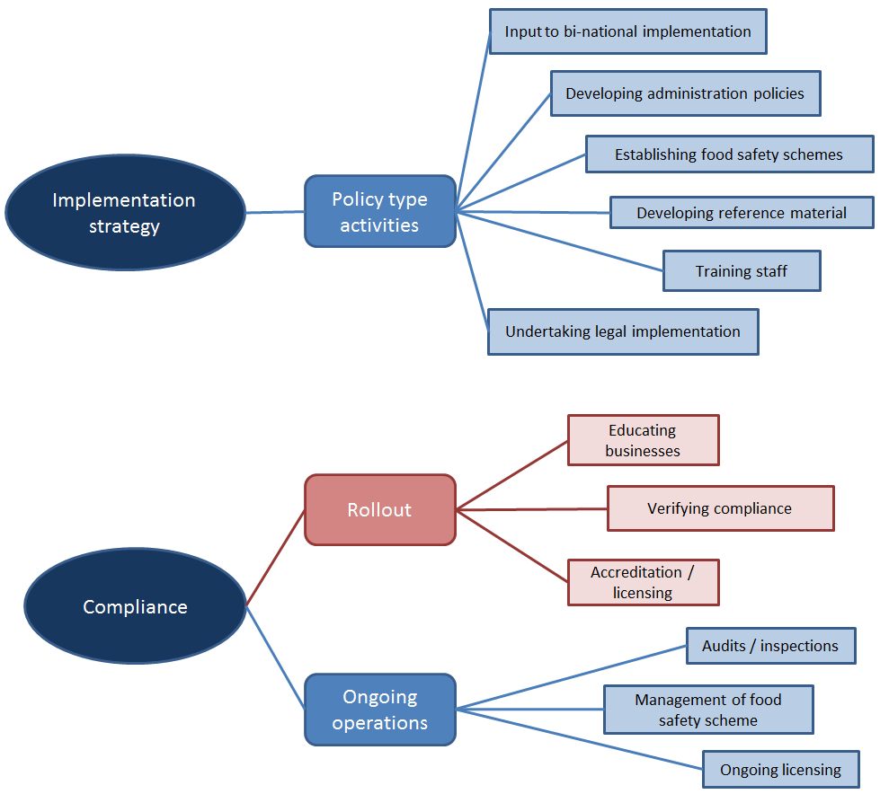
Figure 1. Categorisation of relevant agency activities into FSANZ CBA structure

Agency benefits
To determine the net costs for jurisdictions, benefits also need to be considered. Increases in costs for compliance and enforcement type activities may also be associated with an increase of revenue to the agency from industry cost recovery. This may be in the form of increases in licensing fees, inspection fees (particularly when charged by the hour) or fines from enforcement activities. The most significant benefits include:
- The introduction of increased fee collection for those agencies that cost recover from the industry may result from the introduction of stricter requirements into the Code. For example, introducing a new allergen into the Code may result in longer audits to verify ingredient and production segregation, residual levels testing and appropriate labelling of products. If the agency charges an audit fee then this is an increase in the revenue received by the agency. These activities would be quantified in FTEs as they are captured in the compliance and enforcement costs mentioned above and would be calculated in the same manner. Any increases in regulatory fees incurred by businesses due to a change to the Code would be captured in the business segment of the FSANZ CBA. For example, figures received from Victoria indicate that approximately 60% of the total food regulatory expenses are cost recovered, which would be captured in business costs in a RIS. The ‘dollar is a dollar’ approach to the CBA means that any transfers between community subgroups are ‘cancelled out’ in the bottom line. This case could be represented in the CBA as factors such as longer audit FTE costs are incurred by an agency, the increased cost recovery fee is a cost incurred by the business, and the cost recovery fee received by the agency is a benefit to the agency. The agency incurs a cost to undertake the audit, the business incurs a cost to recompense the agency for the audit and the agency receives a benefit in terms of the payment received from the business. The recovery process therefore ‘cancels out’ and only the cost to the business would be captured in the end CBA figures.
- Expected fines collected through enforcement of noncompliant businesses are not reflected in FSANZ CBA, as the expectation is that businesses will comply with any new regulation.
- The cost of foodborne illness outbreaks can be significant, such as the cost to the jurisdictions of providing healthcare, and lost productivity. Some changes to the Code aim to reduce the likelihood of a foodborne illness outbreak. Reducing the average number of these outbreaks is of benefit to the jurisdictions, but the overall community benefit of these outbreaks is calculated from the Cost of illness model previously mentioned and thus out of scope of the Government Cost Framework (to avoid double-counting). This may be an area for future work.

Government Implementation Cost Framework
The framework sets the policy for incorporating government implementation costs into FSANZ CBA and is the application of the findings of the project. It will be possible to vary the approach if needed on a case-by-case basis. The cost predictions generated from the framework will be discussed with the jurisdictions as part of development of any RIS.
The framework provides:
- An early indication of the significance of the potential government implementation costs through an indicative materiality decision tool (Materiality tool). Each risk management option will be tested for the likelihood of significant government costs. If the early indication is that government implementation costs may be significant, such that they could influence the outcome of a CBA, then the user should proceed to using the costing tool. Significance is a contextual conclusion and other segments of the CBA, such as consumer and business costs, need to be considered in determining the significance of government implementation costs. In some instances, an industry or affected businesses may be concentrated in a small number of jurisdictions. This may mean that costs are high for these jurisdictions, but are not significant in the entire context of the CBA. If costs are likely to be burdensome to one or more jurisdictions, it may be appropriate to undertake further investigation even where the jurisdictions’ costs, in total, are not significant to the CBA.
- Quantification of the government implementation costs associated with new or revised food standards through the use of the costing tool (Costing tool). After using the materiality tool to conclude that government implementation costs may be significant for the risk management option, the costing tool can be used to provide an estimate of the likely cost. This estimate will be the starting point for costs reported in the consultation RIS. The costing tool uses the before mentioned structure of agency implementation activities which allows for costs to be separated into ‘once-off’ and ‘ongoing’ costs for sensitivity and discounting calculations.
- A starting point to effectively engage with the agencies on the estimation of their implementation costs. The values calculated by the model will act as the starting point for further discussions with jurisdictions.
The structure used in the framework aligns, as best able, with self-described agency activities. It is anticipated that this structure provides an intuitive breakdown of the activities that will assist agencies in identifying where the expected implementation costs could deviate from the FSANZ estimate. This will allow FSANZ to collect more detailed and consistent activity and cost data information from the agencies than has previously been possible. This feedback from the agencies will provide a more accurate estimate of the implementation cost for the final decision RIS and will be fed back into FSANZ’s underlying cost data, which will improve the accuracy of the costing tool.
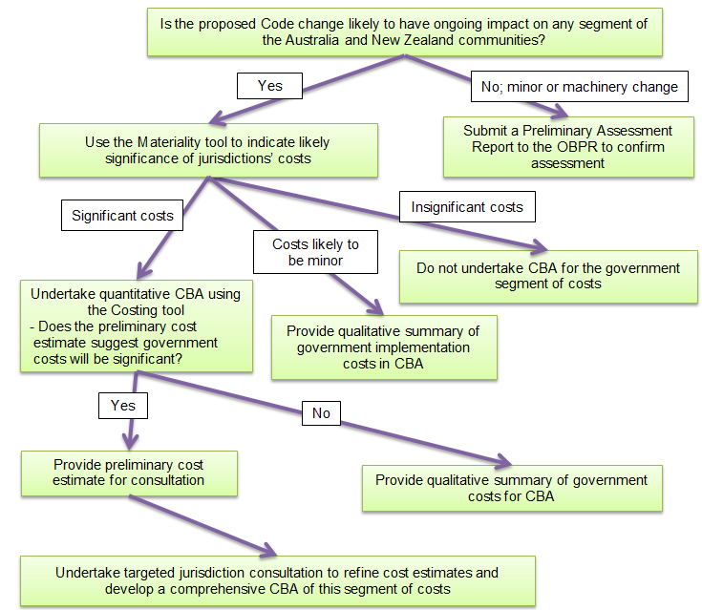
Figure 2. Flow chart of FSANZ’s process for using the Government Implementation Cost Framework

Materiality decision tool
Reducing the uncertainty of the estimate of net jurisdictions’ costs should be considered where their costs are likely to be significant. ‘Significance’ in this case refers to the likelihood that this segment of costs will influence the preferred risk management option. This means that there are two aspects to determining significance, namely:
- likely magnitude of the jurisdictions’ net costs
- likely magnitude of the other net costs captured in a FSANZ CBA (i.e. consumer and industry net costs).
A number of aspects, or cost drivers, of typical changes to the Code have been identified that influence the effort (cost) necessary for agencies to incorporate Code changes into their food regulatory systems. The number of cost drivers associated with the proposed change and their likely size will give an indication as to whether the jurisdictions’ net costs are likely to be significant. Cost drivers need to be considered within the context of likely net costs of the other community segments in order to determine overall significance in terms of CBA.
The materiality tool can provide an indication of the likely significance of the jurisdictions’ net costs.
The materiality tool considers the factors that will influence the amount of work required to undertake implementation activities.
Factors that may influence significance of government implementation costs include:
- The likelihood of the risk management option involving Code change.
- The complexity of change to the Code.
- The presence, structure, distribution and size of the industry in the jurisdiction.
- Whether the industry is presently regulated and the level of that regulation. If the industry was not previously regulated in the jurisdiction (beyond standard food safety requirements), identifying the relevant businesses in jurisdictions can be a costly exercise. The amount of training for agency staff, local governments, auditors, inspectors and businesses would be expected to be higher as they learn about the intricacies of the industry as well as the new regulation and how it should be enforced.
- The skills and systems that industry may already have in place to manage the new regulatory requirements. This affects the amount of training necessary for effective implementation and/or the reference material needed. Smaller businesses were reported to require a disproportionate amount of regulators time. For this reason, the number of small businesses will be used as a proxy for the factor ‘food safety sophistication’ of businesses within the jurisdiction. The food safety sophistication of the affected businesses is represented by the ‘Number of small businesses affected by the change’ question in the materiality tool.
- The likelihood that jurisdictions will require the businesses to hold a new food safety program, or alter an existing food safety program.

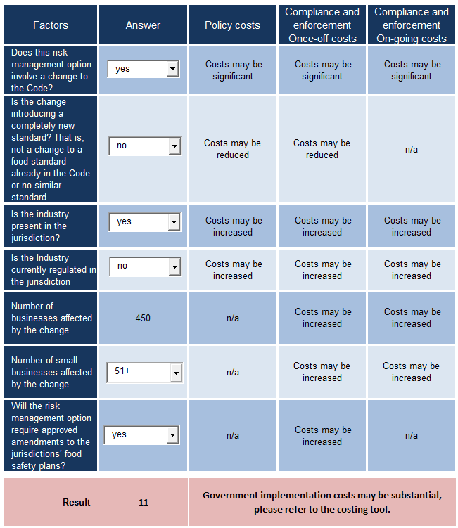Figure 3 A. Examples of cost drivers affecting the expected significance of government implementation costs.
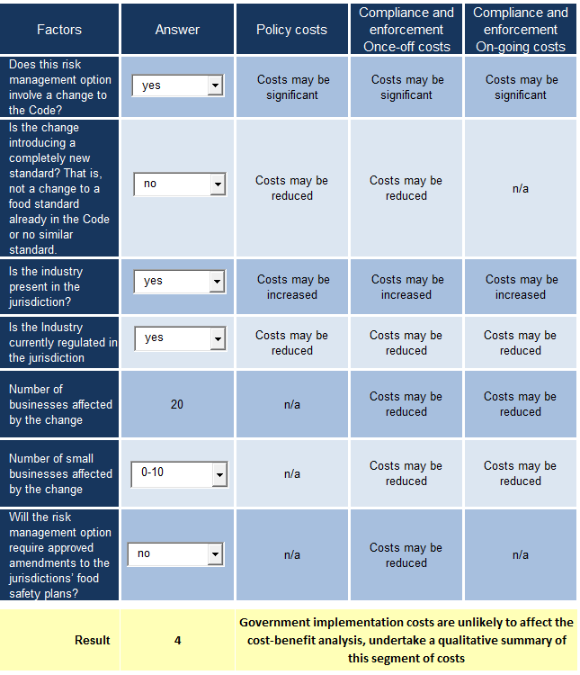 Figure 3 B. Examples of cost drivers affecting the expected significance of government implementation costs.

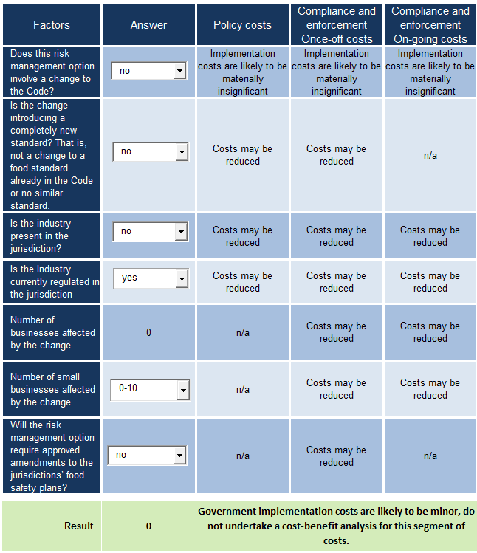
Figure 3 C. Examples of cost drivers affecting the expected significance of government implementation costs.

Costing tool
The costing tool can be used to provide an estimate of the jurisdictions’ implementation costs, particularly where the indicative decision tool suggests that jurisdictions’ implementation costs may be significant for determining the preferred option.
This estimate will be the starting cost figure reported for the risk management option to be included in consultation with the jurisdictions.
The costing tool is built around information and data provided during consultation with the agencies. The tool is based on a simplified activity-based costing approach and involves:
- Identifying the key activities involved in introducing new or revised standards into the jurisdictions’ food regulatory system (e.g. additional time at an audit would be needed to explain the new requirements to businesses).
- Collecting general cost data from the agencies that will allow for estimates of per unit costs of the activities (e.g. an audit may cost $250 per hour). These figures are the cost dataset that underpins the costing tool.
- Estimating the effort involved to undertake an implementation activity (e.g. the new standard may involve an additional half an hour at an audit to explain the changes to more sophisticated businesses, and an hour per audit at smaller businesses).
- Calculating the implementation cost to each agency by looking at the activities they undertake and the cost of those activities.
- Aggregating the net costs for the agencies in the jurisdiction to determine the net jurisdictional cost, and from this the Australian and New Zealand net government implementation costs.
Over time as this framework is used in FSANZ food standards development projects, the data will improve, which will be reflected in the preliminary cost estimates.
Separate cost estimations are required for each jurisdiction due to factors such as the presence or absence of industries and jurisdiction-specific food regulations. For example, chapters three and four of the Code are not mandatory in New Zealand. Where New Zealand decides to not adopt FSANZ changes to these chapters into their food safety system they will not incur costs related to their implementation.

The process of using the costing tool in the RIS structure
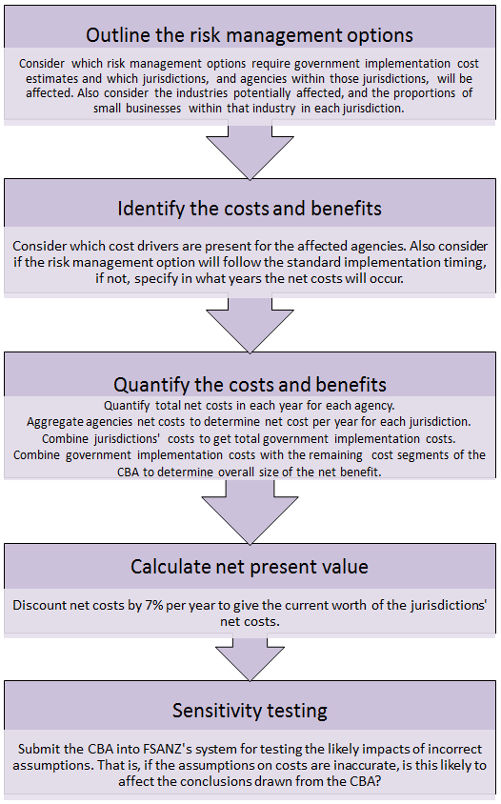
Figure 4. The process of using the costing tool within the RIS structure

Quantifying costs and benefits
Below is a data capture form from the costing tool and some brief discussion on how it should be filled out. This process requires a good knowledge of the industry sector and the regulatory and non-regulatory options being considered.
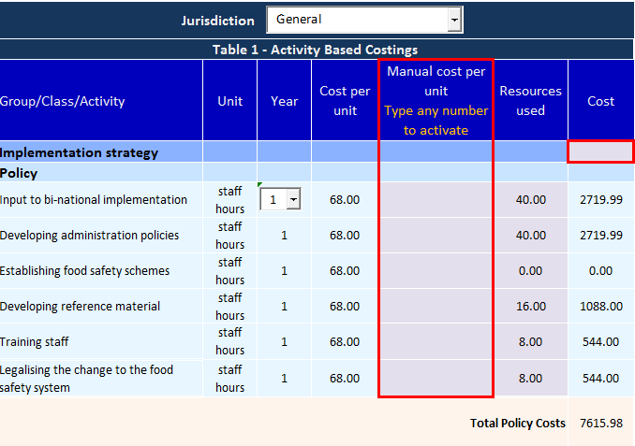
Figure 5. Example costing tool – Implementation strategy cost category
In order to calculate the jurisdictions’ costs per year:
- Indicate which year you are calculating costs for, with zero being the year the Code change was finalised.
- Indicate how many resources are used per activity for that year. All activities in the above Figure 5 are calculated in staff-hours.
- Undertaking the first two steps provides the total costs for that year per Cost category that is Implementation strategy, Roll-out and Ongoing operations.
A more extensive example of the completion of these fields is provided in Appendix 4.
Filling out the form requires a good knowledge of what is being proposed and the present level of regulatory oversight of the industry. A couple of diagrams have been developed below to show how this can be thought about in different situations.
If the businesses were already subject to food regulation through ongoing operational compliance work, then the status quo would include a baseline of activity in this category, as represented below in Figure 6A. The costing tool seeks to isolate the incremental or marginal work associated with incorporating new or revised food standards into their regulatory systems, as represented as the areas under the curves shown as double arrows. In this case, there would be no or only minimal, costs incurred in the ‘Ongoing compliance’ cost category.

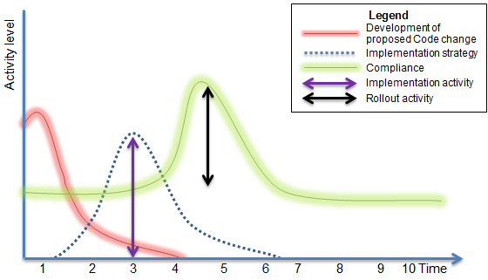
Figure 6 A. Examples of typical timings of implementation phases for Code changes
However, for businesses that are not currently captured in the jurisdiction’s food regulatory system, there is no baseline ongoing compliance work component. This situation is represented below in Figure 6B. This means that all ongoing operational compliance costs would be relevant to the CBA as the costs are incurred as a direct result of a Code change. There would be a cost reflected in the ongoing operational compliance cost category in this case.

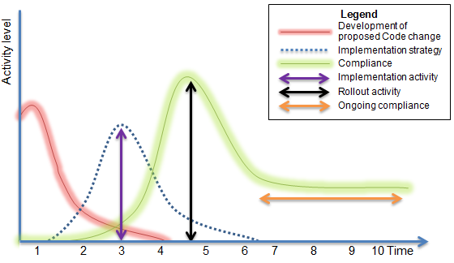 Figure 6 B. Example of typical timings of implementation phases for Code changes where businesses are not currently regulated

Calculating net present value
The timing of typical implementation activities is important in calculating the net present value of jurisdictions’ costs. Activities will be assumed to occur as indicated in the shaded years in Figure 7 below for the purpose of the preliminary cost estimate. agencies will have the opportunity to justify why the standard timeline may not be appropriate for the particular proposed change during the consultation process.
After calculating the costs using the above steps, the cost per year is discounted by 7% per year in order to calculate the total net cost at year 0 prices. This provides the net present value at year 0.
The net present value is then combined with other data from the overall CBA for sensitivity testing and analysis.
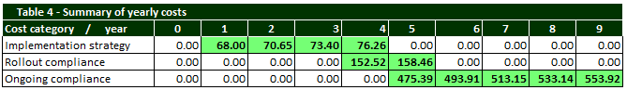
Figure 7. Standard implementation timings for CBA, represented by highlighted cells.

Engaging with agencies on-costs
Early engagement with the jurisdictions will be undertaken by FSANZ if the costing tool indicates that government implementation costs may be significant.
The limitations in the dataset underpinning the costing tool means that additional effort may sometimes be needed to obtain better quality cost estimates. Where government implementation costs are likely to influence the outcome of the CBA, consultation will be critical in reducing the uncertainty of the estimates.
The framework allows data to be gathered more efficiently as it provides a basis for discussion between FSANZ and the agencies to reconcile FSANZ cost estimates with the agencies expected costs. These discussions may lead to improvements in the cost predictions that will in turn be incorporated into underlying data to improve future preliminary estimates.

Possible next steps
The Government Implementation Cost Framework is intended to undergo further development and refinement over time as information and data improves, and as experience in using the framework is built.
As the agencies’ data underpinning the costing tool improves, it should be possible to further refine the boundaries of the cost drivers. Improving the accuracy of the preliminary government implementation costs will reduce the reliance on the agencies to justify how they expect their costs to deviate from the estimate during consultation. Some potential areas for further exploration include:
- Real time activity tracking during the implementation lifecycle—providing a data collection tool to the agencies to track effort (staff time) for various activities during the implementation lifecycle.
- Fee changes monitoring during years of substantial implementation work for fully cost recovered agencies. This project focused on ‘bottom-up’ or micro costing where underlying activities involved in implementation were identified. Another tactic may be to consider gross costing, such as identifying a year involving significant implementation work and considering the movement in fees charged by fully cost-recovered agencies.
- Using expert elicitation to refine the cost estimates and further explore the boundaries of the cost drivers.
- Undertaking a comprehensive review process involving a
pre-and post-implementation evaluation of the performance of the framework. The case studies highlighted that there is potential to have significant difference between estimated cost and those experienced. FSANZ will continue to evaluate case studies to help establish the reasonableness of assumption applied and make better use of sensitivity analysis where key assumptions are likely to be critical to the outcome of the analysis.

Conclusions
This project examined how changes to the Code affect the jurisdictions and how this could be quantified in FSANZ’s CBA. This has included a practical determination as to what costs should be included for an OBPR compliant CBA.
From this, the Government Implementation Cost Framework has been developed and includes:
- a materiality tool for indicating when government costs will be material in FSANZ’s CBA
- a costing tool for assessing and quantifying the jurisdictions’ implementation costs associated with changes to the Code.
The jurisdictions’ cost of introducing changes to the Code into their food regulatory system may be a significant component in the CBA that FSANZ undertakes to assess potential changes to the Code.
There are inherent differences between the jurisdictions such as the composition of the food industry and existing state regulations that will cause the implementation cost to vary between jurisdictions. This framework enables relevant costs to be identified and collected to facilitate CBA.
This framework will improve the transparency, timeliness and quality of FSANZ CBA work allowing for more informed decisions when determining the appropriateness of changing the Code.

Appendix 1 – Components of the cost-benefit analysis
FSANZ undertakes the following steps in order to meet COAG RIS requirements as set out in the below diagram.
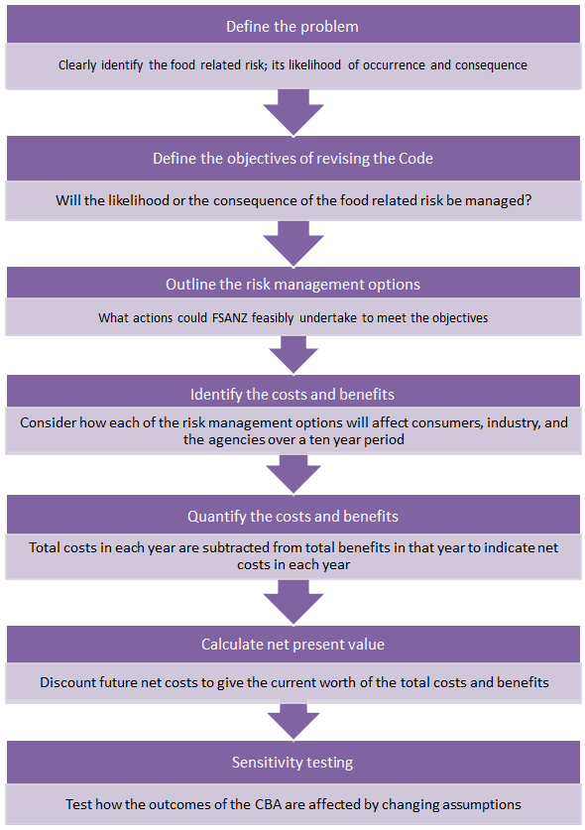
Figure 8. Key steps in the FSANZ RIS process
This process requires that all the major costs and benefits of the feasible options being considered be quantified in monetary terms where possible. In this way, the outcomes of a range of options are translated into comparable terms in order to facilitate, comparison, evaluation and decision-making.
The status quo or ‘do nothing’ option is always included as the baseline option to compare the other options against.
There are three main segments of the community that FSANZ considers in a CBA:
- Consumers, or the community in general. All people in Australia and New Zealand consume food products and thus may be affected by changes to the Code, such as through a reduction in the products available, increased food costs from food businesses passing higher regulation costs onto consumers or increased safety of the food they eat.
- Industry. Food production businesses may be affected by changes to the Code, for example through higher compliance costs from increased microbiological testing or more stringent record keeping requirements.
- Government agencies. FSANZ works in partnership with the jurisdictions’ agencies to ensure an effective food regulatory system. Changes to the Code may affect agencies as they implement the changes into their food regulatory system.
The costs and benefits associated with a change to the Code are estimated for each of the segments identified above. The costs and benefits are typically considered over a ten-year period. By considering how different community subgroups are affected over ten years, the major phases of implementing new regulation are able to be included in the CBA. These include:
- implementation strategy or detailed planning of the rollout of the new regulation
- rollout or physical implementation
- hand-over to ongoing operations or the ongoing administration of the regulation.
In order to combine the net costs from each of the years to arrive at a single net cost figure, the net costs are converted to the net present value. This is done in order to take the time value of money into account. The net costs from future years are discounted by 7% per year and then totalled. This gives the current worth of the total costs and benefits that arise from the regulatory change over a ten-year period. If the net present value is clearly positive (after uncertainties in the cost estimates have been accounted for) then it is expected that there will be an overall benefit to the Australian and New Zealand communities.
The costs and benefits to all community subgroups are added without regard to the individuals to whom they accrue. A $1 gain to one person cancels a $1 loss to another. This ‘a dollar is a dollar’ assumption enables resource allocations to be separated from distributional effects for the purpose of CBA.
In order to build a comprehensive CBA, it is important that agencies’ cost of incorporating Code changes into their food regulatory system be considered and captured as appropriate.

Appendix 2 – Australian and New Zealand Regulatory Agencies
New South Wales’ food regulatory agencies are:
- NSW Food Authority, whose responsibilities include policy design, coordination and implementation, and ensuring compliance of producers, manufacturers, and transport.
- Local Councils whose responsibilities include ensuring compliance of retail (excluding meat).
Victoria’s food regulatory agencies are:
- Department of Economic Development, Jobs, Transport and Resources, whose responsibilities include ensuring compliance of primary industries, eggs, and sprouts.
- Department of Health and Human Services (Food Safety Unit), whose responsibilities include policy design, coordination and implementation.
- Primesafe, whose responsibilities include ensuring compliance of meat and seafood.
- Dairy Food Safety Victoria, whose responsibilities include ensuring compliance of dairy.
- Local Councils, whose responsibilities include ensuring compliance of all remaining businesses.
Queensland’s food regulatory agencies are:
- Food Safety Policy and Regulation Section (within Department of Health), whose responsibilities include policy design, coordination and implementation, and compliance of producers and manufacturers.
- Safe Food Production Queensland, whose responsibilities include ensuring compliance of primary producers; meat, dairy, eggs.
- Local Councils, whose responsibilities include ensuring compliance of retail (excluding meat).
Western Australia’s food regulatory agencies are:
- Food Unit (within Department of Health), whose responsibilities include policy design, coordination and implementation, and ensuring compliance of everything except most retail.
- Local Councils, whose responsibilities include ensuring compliance of retail.
South Australia’s food regulatory agencies are:
- Food Safety and Nutrition Branch (within SA Health), whose responsibilities include policy design, coordination and implementation, and ensuring compliance of vulnerable populations.
- Biosecurity SA, whose responsibilities include ensuring compliance of primary production; meat, seafood, citrus, eggs.
- Dairy Authority of South Australia, whose responsibilities include ensuring compliance of dairy.
- Local councils, whose responsibilities include ensuring compliance of manufacturing, transport, retail.
Tasmania’s food regulatory agencies are:
- Food safety division (within the Department of Health and Human Services), whose responsibilities include policy design, coordination and implementation.
- Biosecurity Tasmania (within the Department of Industries, Parks, Water and Environment), whose responsibilities include ensuring compliance of primary production and processing sectors.
- Tasmanian Dairy Industry Authority, whose responsibilities include ensuring compliance of dairy.
- Local Councils, whose responsibilities include ensuring compliance of manufacturers, transport, and retail.
Northern Territory’s food regulatory agencies are:
- Food Safety Section (within the Department of Health), whose responsibilities include policy design, coordination and implementation, and ensuring compliance of everything.
Australian Capital Territory’s food regulatory agencies are:
- Health Protection Service, whose responsibilities include policy design, coordination and implementation, ensuring compliance of everything.
Commonwealth Government of Australia’s food regulatory agencies are:
- Department of Agriculture and Water Resources, whose responsibilities include ensuring compliance of imported food.
New Zealand’s food regulatory agencies are:
- Ministry for Primary Industries (MPI), whose responsibilities include policy design, coordination and implementation, and ensuring compliance of everything.
- Local councils, whose responsibilities include ensuring compliance of retail.

Appendix 3 – Survey Participants
New South Wales participants:
- NSW Food Authority
- Bega Valley Shire Council
- City of Sydney Council
Victoria participants:
- Department of Economic Development, Jobs, Transport and Resources
- Department of Health and Human Services (Food Safety Unit)
- Primesafe
- Dairy Food Safety Victoria
- Knox City Council
- Corangamite Shire Council
Queensland participants:
- Safe Food Production Queensland
- Brisbane City Council
- Burdekin Shire Council
Western Australia participants:
- Food Unit (within Department of Health)
- City of Cockburn Council
- Shire of Augusta Margaret River
South Australia participants:
- Food Safety and Nutrition Branch (within SA Health)
- Biosecurity SA
- Dairy Authority of South Australia
- Eastern Health Authority
- Renmark Paringa Council
Tasmania participants:
- Food safety division (within the Department of Health and Human Services)
- Biosecurity Tasmania (within the Department of Industries, Parks, Water and Environment)
- Tasmanian Dairy Industry Authority
- City of Hobart Local Council
- Meander Valley Council
- Glenorchy City Council
Australian Capital Territory participants:
- Health Protection Service
Commonwealth participants:
- Department of Agriculture and Water Resources

Appendix 4 – Quantifying jurisdictions’ costs

Example 1; small review of existing standard
In order to calculate the jurisdictions’ costs per year consider the activities that would be involved to introduce the revised standard into the jurisdictions’ food safety system. For example, in year one it may take:
- a week of staff time to attend meetings and provide input to developing the implementation plan for the new standard
- a week of staff time to incorporating the standard into existing administrative processes, such as updating computer databases
- two staff days to review and update information guides for industry, and
- an email to all staff to inform them of the update.
Similar work may be undertaken in year two.
Business compliance with the new standard may be expected from year 4. Compliance may involve:
- an additional two hours with each affected business over the year during their routine audits or inspections.
Year five may involve and additional one hour over the year spent with businesses, although after the businesses had fully integrated the updated standard requirements into their systems, additional time may not be required.
Quantifying a situation such as this may look similar to the below Figure 9 for one jurisdiction.
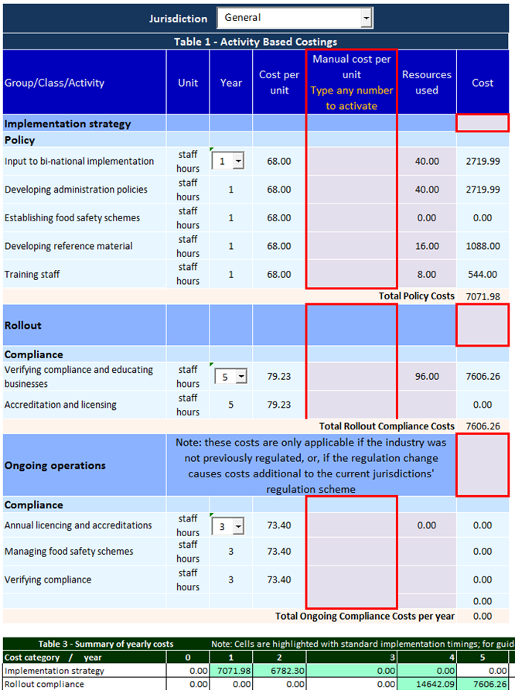
Figure 9. Costing tool example with no ongoing costs.

Example 2; new standard
If introducing a new standard means that a business or industry would be newly captured in the jurisdiction’s food safety scheme then all ongoing costs should be captured in the CBA. This may look like the below example where the annual verification of compliance (e.g. audit or inspection) is calculated from year six onwards.
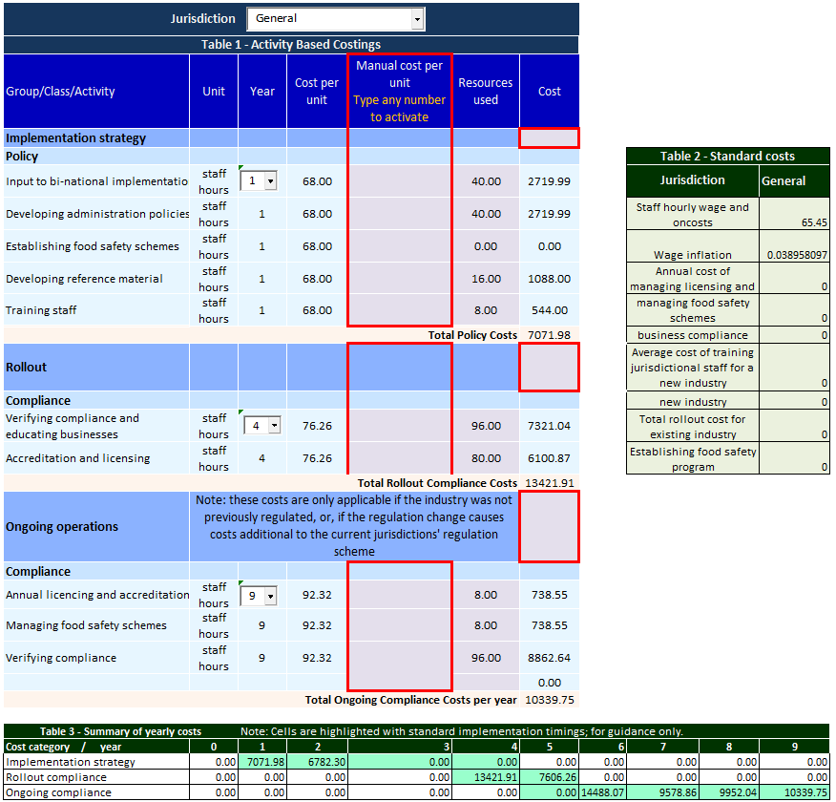 Figure 10. Costing tool example with ongoing costs

link to COAG regulatory impact guidelines
Link to COAG RIS preliminary assessment form
link to FSANZ act.
Refer Appendix 3
Activity-based costing is a costing methodology that identifies all activities in an organisation. Cost per activity is then calculated by its consumption of resources.
7% is the annual real discount rate that OBPR requires for the calculation of net present values. Link to Commonwealth cost benefit analysis guidelines
ibid

